

TEST PLAN PROJECT

NEW UNMANNED AIR VEHICLE FOR SURVEILLANCE OR STRIKE ROLE

**STEVEN MAZZA-VIRNA RAZETTO-KELLEY THOMPSON-NAM TRAM**

OA 4603 TEST & EVALUATION

PROF. THOMAS HOIVIK

NAVAL POSTGRADUATE SCHOOL

3 SEP 2013

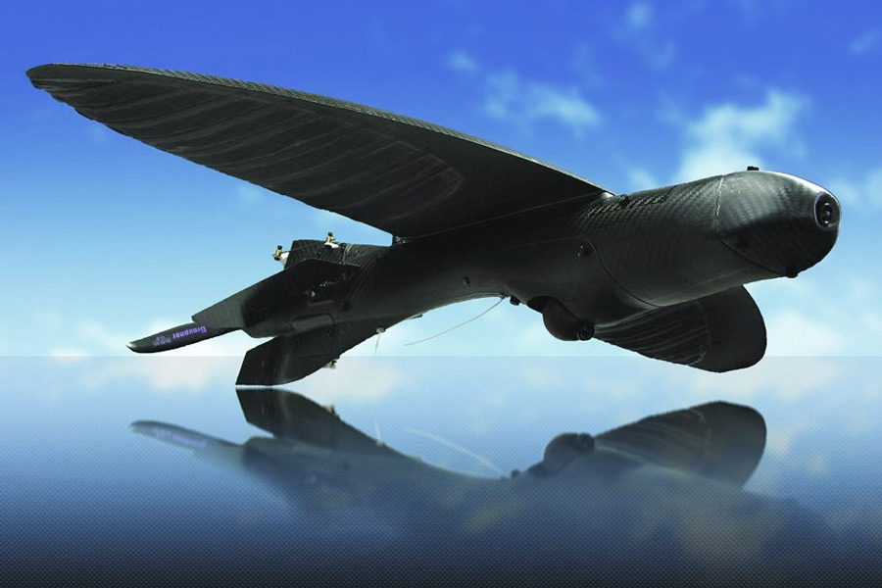

Table of Contents

**1** **INTRODUCTION** 5

**PURPOSE** 5

**SYSTEM DESCRIPTION** 5

**2** **MISSION NEED and OPERATIONAL REQUIREMENT** 5

**MISSION NEED** 5

**OPERATIONAL REQUIREMENTS** 5

**3** **SCOPE AND EVALUATION** 6

CRITICAL TECHNICAL PARAMETERS 6

**GENERAL FUNCTION AND CAPABILITY DENDRITICS** 6

**SUMMARY OF COIs/MOEs/MOPs/DRs** 8

**TEST OBJECTIVE MATRIX** 11

**GENERAL TEST OPERATIONS AND SCENARIO OVERVIEW** 11

**INSTRUMENTATION REQUIREMENTS** 11

**LIMITATIONS AND SCOPE OF TEST** 12

**4** **OPERATIONAL EFFECTIVENESS** 12

**E-TESTS** 13

E-9 (Targeting) 13

E-10 (Firepower) 14

E-1 (Speed) 15

E-2 (Flight Time) 15

**5** **OPERATIONAL SUITABILITY** 16

**S-TESTS** 16

S-1 (Interoperability) 16

S-2 (Human Systems Integration) 16

**ANNEX A:** **RESOURCE REQUIREMENTS** 18

**ANNEX B:** **DATA SHEETS AND QUESTIONNAIRES** 19

**ANNEX C:** **OMITTED** 22

**ANNEX D:** **DATA ANALYSIS PLAN** 23

List of figures

Figure 1. MQ-45 Master Capability Dendritic 7

Figure 2. Communications Capability Dendritic 8

Figure 3. Scenario D Run Profile 14

List of tables

Table 1. Test Objective Matrix 11

Table 2. Limitation Summary 12

# **1 INTRODUCTION**

## **PURPOSE**

The purpose of this test project was to inform the Combat Air Command Commander’s fielding decision of the new Unmanned Aerial Vehicle’s (UAV), the MQ-45 Golden Eagle (MQ-45), operational capability. Team 5 of Summer 2013 OA4603 evaluated the MQ-45’s operational effectiveness, suitability and mission capability.

## **SYSTEM DESCRIPTION**

The MQ-45 is a high altitude, long range, all-weather intelligence gathering unmanned aerial vehicle with limited strike capability. The MQ-45 is equipped with sensors, cameras, an electronic warfare countermeasure suite, and is capable of autonomous flight operations. It is a powered by a single engine and can fly up to 2,000 nautical miles to its target area, loiter overhead for 50 hours, then return to its origin.

# **2 MISSION NEED and OPERATIONAL REQUIREMENT**

## **MISSION NEED**

Overseas presence and power projection are critical elements of the Chairman of the Joint Chiefs of Staff’s 2013 National Military Strategy. The CJCS and the CIA have determined that a need exists for an increased weapons and sensors payload capacity on an unmanned aircraft that will be able to fly to its targets, gather data, and strike much more rapidly. Extended data collection and deep strikes gives deployed US and NATO forces a decisive military advantage and offers the necessary intelligence to support on-going operations. Current operational UAV systems are lacking in endurance and are susceptible to enemy targeting and tracking. With its enhanced capabilities, Golden Eagle can augment the intelligence mission when tracking, collecting and hunting down enemy targets for extended periods. The Air Combat Command Commander has validated the need for an unmanned aerial vehicle that can penetrate deep within the operational arena in support of Enduring Freedom.

## **OPERATIONAL REQUIREMENTS**

The Operation Requirements of the MQ-45 identify the essential capabilities, the performance measures and the processes or series of actions to be taken in effecting the results that are desired in order to address the ISR and Strike mission areas. Operational Requirements of the MQ-45 are as follows:

* The MQ-45 shall be flown by a 2 pilots.
* The MQ-45 must be fully transportable and compartmentalized into no more than six pieces.
* The MQ-45 must be transportable by a C-130. (Need description of C-130)
* The MQ-45 must be able to land and take off within 1000ft. (Is this radius?)
* Time to reassemble the MQ-45 shall not exceed six hours. (What about take apart?)
* The Synthetic Aperture Radar must capable to see through haze, clouds and smoke.
* The cameras must be high definition, night vision and inferred and capable of producing full motion video.
* Line of site connectivity must be C-band.
* Beyond line of site connectivity must be Ku-band.
* The MQ-45 must reach a maximum altitude of 75,000 ft.
* Joint Force Commanders must be able to receive radar imagery in real time.
* The MQ-45 shall direct stationary and moving targets with precision guided munitions.
* The MQ-45 shall neutralize an enemy radar within a 50 mile radius.
* The reliability of hit the MQ-45 precision guided munitions shall be 0.99.
* The reliability of kill of the MQ-45 precision guided munitions shall be 0.98.
* Video/Camera/SAR shall have a combined operational availability of 0.95.
* Optics must view target up to 110 km.
* The MQ-45 shall carry a payload up to 4700 lbs. (Is it OK to have a mixture of units? lbs and km?)
* MTBF shall be 250,000 hours at a 95% CL. (Spell out CL)
* The MQ-45 shall carry up to 1000 lbs of aircraft engine fuel. (Use aviation fuel instead?)
* The MQ-45 software maintenance shall be capable of software uploads while in flight.
* The MQ-45 shall be operable in autonomous mode.
* Satellite connectivity must be UHF and SHF.
* Flight avionics must be redundant.

These requirements served as the basis for determining the operational effectiveness and suitability of the vehicle in order to declare success for the test phase

# **3 SCOPE AND EVALUATION**

## CRITICAL TECHNICAL PARAMETERS

## **GENERAL FUNCTION AND CAPABILITY DENDRITICS**

Effectiveness capabilities of the MQ-45 were branched out into the following functional areas: Autonomy; Communications; Compatibility; Data Collection; Interoperability; Lethality; Resupply; Sensing; and Targeting and Transportability. Figure 1 illustrates the MQ-45 functions with limited capabilities and Figure 2 depicts the Communications capability in detail.



Figure 1. MQ-45 Master Capability Dendritic



MCS

Link 11

Imagery

2.4kb/s

**Communications**

Tactical Data Links

Link 16

Digital Voice

16kb/s

Secure Texts

TC/IP

SATCOM

Ka

UHF

Ku

SHF

Figure 2. Communications Capability Dendritic

TCP/IP

## **SUMMARY OF COIs/MOEs/MOPs/DRs**

This section summarizes the Critical Operational Issues (COI), Measures of Effectiveness (MOE), Measures of Performance (MOP) and Data Requirements (DR) of the MQ-45 Golden Eagle. The COIs determine the MQ-45’s capability to perform its mission. The MOEs indicate the degree to which the MQ-45 performed the tasks or met a required specified condition. The MOPs measure the MQ-45’s capability to accomplish the tasks. The DR is a number or some other item that applies to the MOP.

**Operational Effectiveness:**

COI 1. Is the MQ-45 range sufficient to support the mission?

MOE 1.1 Probability of flying up to 75,000 ft.

MOP 1.1.1 Maximum Altitude

MOP 1.1.2 Average time to maximum altitude

MOE 1.2 The probability of flying for 50 hours

MOP 1.2.1 Average flying time at maximum speed

MOP 1.2.2 Average flying time at minimum speed

DR 1.2.2.1 Number of sorties

COI 2. Is the MQ-45 set up time sufficient to support the mission?

MOE 2.1 Probability of setting up in 6 hours

MOP 2.1.1 Average set up time

MOP 2.1.2 Minimum set up time

DR 2.1.2.1 Start time

MOE 2.2 Probability of successful set up

MOP 2.2.1 Average number of people required for set up

MOP 2.2.2 Minimum number of people required for set up

COI 3. Can the MQ-45 maneuver through hazardous environment?

MOE 3.1 Detection Avoidance

MOP 3.1.1 Detection avoidance proportion

MOP 3.1.2 Detection survivability ratio

MOE 3.2 Acquisition Avoidance

MOP 3.2.1 Average exposure time

MOP 3.2.2 Acquisition survivability ratio

MOE 3.3 Hit Avoidance

MOP 3.3.1 Hit survivability ratio

MOP 3.3.2 Average time from missile detection until missile impact

DR 3.3.2.1 Number of sustained hits

COI 4. Can the MQ-45 engage enemy threat?

MOE 4.1 Probability of hitting enemy target

MOP 4.1.1 Mean time to engage enemy threat

MOP 4.1.2 Percent of enemy threat hits

DR 4.1.2.1 Number of enemy kills

MOE 4.2 Probability of surviving enemy engagements

MOP 4.2.1 Average time to detect enemy targets

MOP 4.2.2 Percent of enemy targets destroyed (same as hits?)

COI 5. Can the MQ-45 collect ISR data to support the mission?

MOE 5.1 Target tracking accuracy

MOP 5.1.1 Percentage of moving targets successfully detected

MOP 5.1.2 Percentage of moving targets successfully classified

DR 5.1.2.1 Number of targets

MOE 5.2 Imagery

MOP 5.2.1 Visible NIIRS (spell out NIIRS)

MOP 5.2.2 Percentage of moving/stationary targets successfully classified

MOE 5.3 Activity

MOP 5.3.1 Proportion of rejected images

MOP 5.3.2 Percentage of moving/stationary targets successfully classified

COI 6. Are the optics capable of seeing beyond the line of sight in all weather?

MOE 6.1 Continuous connectivity

MOP 6.1.1 Throughput

MOP 6.1.2 Data transmission rate

DR 6.1.2.1 Number of hours without disruption

MOE 6.2 Receiving capability

MOP 6.2.1 Message accuracy

MOP 6.2.2 Average time to acknowledge report

COI 7. Will the susceptibility and vulnerability characteristics of the MQ-45 allow the successful completion of its mission in its intended operating environment?

MOE 7.1 Probability of destruction

MOP 7.1.1 Average time before enemy detection

DR 7.1.1.1 Flight hours

COI 8. Will the MQ-45 be safe to operate in a combat environment?

MOE 8.1 Threat Effects Avoidance

MOP 8.1.1 Performance and Survivability Ratio (PSR)

MOP 8.1.2 Threat effects survivability ratio

DR 8.1.2.1 Egress point

COI 9. Is the MQ-45 interoperable with other C4I systems?

MOE 9.1 Probability of successful communication

MOP 9.1.1 Average time to establish communications

MOP 9.1.2 Average data rate

MOE 9.2 Mission Management

MOP 9.2.1 Average time to manage mission scheduling

DR 9.2.1.1 Air Tasking Order

MOE 9.3 Situation Development

MOP 9.3.1 Average time to generate intelligence report message

DR 9.3.1.1 Intelligence Reports

COI 10. Will the MQ-45 detect the threat in a combat environment at adequate range to allow successful engagement?

MOE 10.1 Situation Awareness

MOP 10.1.1 Proportion of threats outside effective range at initial display

MOP 10.1.2 Average System Response time (ASR)

DR 10.1.1.1 Number of correctly identified threats

**Operational Suitability:**

COI 11. Will the human factors aspects of the MQ-45 support completion of the aircrafts mission?

MOE 11.1 Human Factors Engineering

MOP 11.1.1 Maintenance Error

DR 11.1.1.1 Mishap Reports

MOE 11.2 Fatigue

MOP 11.2.1 Average time to complete a task

DR 11.2.1.1 Workload

MOE 11.3 Training

MOP 11.3.1 Task success rate

MOP 11.4.1 Operations Instructions Manual

COI 12. Is the MQ-45 firepower satisfactory for the strike mission?

MOE 12.1 Engagement

MOP 12.1.1 Average range of engagement

MOP 12.2.1 Proportion of strike missions completed

DR 12.2.1.1 Reason for no engagement

Switch COI 9 and COI 12 because interoperability is suitability and firepower is not

## **TEST OBJECTIVE MATRIX**

|  |  |  |
| --- | --- | --- |
| COI | Test Objectives and Sub Objectives | Test |
| 1. Mobility | To determine the capability of the UAV   * Maximum altitude (E-1a) * Average time to maximum altitude (E-1b) * Average time at maximum speed (E-1c) * Average time at minimum speed (E-1d) | E-1 |
| 2. Maintainability | To determine the required maintenance   * Average set up time (E-2a) * Minimum set up time (E-2b) * Average number of people required for set up (E-2c) * Minimum number of people required for set up (E-2d) | E-2 |
| 3. Survivability | To determine the ability for the UAV to survive   * Avoidance rate (E-3a) * Survivability rate (E-3b) * Average detection time (E-3c) | E-3 |
| 4. Lethality | To determine the ability to engage enemy threats   * Mean time to engage enemy threat (E-4a) * Percent of enemy threats hit (E-4b) | E-4 |
| 5. Data Collection | To determine the ability to collect data | E-5 |
| 6. Sensing | To determine the accuracy of the sensors   * Range (E-6a) * Resolution (E-6b) | E-6 |
| 7. Reliability | To determine the suitability for use in operationally relevant environment | E-7 |
| 8. Safety | To determine the level of protection to the UAV   * Detection (E-8a) * Evasion (E-8b) | E-8 |
| 9. Interoperability | To determine the accuracy of the data transfer | S-1 |
| 10. Targeting | To determine the accuracy of the sensors   * Range (E-9a) * Speed (E-9b) | E-9 |
| 11. HSI | To determine the clarity of the video | S-2 |
| 12. Firepower | To determine the impact of the weapons   * Lethality (E-10a) * Rate of Fire (E-10b) | E-10 |

Table 1. Test Objective Matrix

## **GENERAL TEST OPERATIONS AND SCENARIO OVERVIEW**

The primary objective was to evaluate the MQ-45 in various operationally realistic environments. Desired test environment included extreme weather conditions and simulated hostile territories. Scenarios were developed to employ the aircraft in different operating environments during each sortie.

**Operational Scenarios**

1. Scenario A. Aerial Patrol

*This scenario will evaluate the ability to provide protection to a group of ground forces*.

1. Scenario B. Battle Damage Assessment

*This scenario will evaluate MQ-45’s ability to successfully characterize the battlespace after combat engagement.*

1. Scenario C. Interoperability Employment

*This scenario is developed to demonstrate the functionality of MQ-45’s various sensor interfaces from the control element to external users.*

1. Scenario D. Convoy Route Clearance

*This scenario will evaluate MQ-45’s ability to map sufficient routes and engage enemy obstacles to allow for successful for ground convoy operations.*

## **INSTRUMENTATION REQUIREMENTS (Need to match Annex A?)**

Instrumentation required test sites that represent the operational environment as much as possible. Although the dry lake bed at Edwards AFB, CA, was solely used for Scenarios A and B, elements of all scenarios were capable of being carried out at the contractor facility. The contractor developed Electronic Ground Support Equipment used for Scenario C. To reduce flight time, Scenario’s B and D was conducted with the MQ-45 Flight Simulator (GEFS) that is designed with a mock-up of its onboard sensors and avionics.

## **LIMITATIONS AND SCOPE OF TEST**

Real world events and higher headquarters taskings could impact the availability of test assets and therefore test activities along with the data collected. Furthermore, the availability is limited to only one aircraft with limited spares. Reduced funding for FY13 has reduced testing to a maximum of 3 flights per month. Table 2 summarizes the test limitations and describes the effects on relevant COIs.

| Limitation | Mitigation | Relevant COIs | Impact |
| --- | --- | --- | --- |
| Limited flight hours for reliability, maintainability, and availability purposes | Use aircraft readiness model projections | COI 1, COI 2, COI 10,  COI 12 | Increased reliance on modeling for reliability and availability |
| Lack of real world threats | Use flight simulators | COI 3, COI 4, COI 7, COI 10 | Failure to evaluate the susceptibility of the aircraft |
| Inadequate test budget | None | COI 1, COI 5, COI 7 | Increased reliance on modeling and simulation |
| Lack of spare parts | None | COI 2, COI 9, COI 11 | Failure to accredit the durability and reliability of the aircraft |
| Unable to test under environmental extremities | Move assets to different test site | COI 3, COI 5, COI 6 | Failure to evaluate the capability to operate in all weather conditions |
| Platform availability | None | COI 1, COI 2, COI 5, COI 9, COI 11 | Increased reliance on modeling and simulation |
| Lack of specified Jammer | Use alternate ECM | COI 3, COI 10 | Electronic protection test results may vary |
| Lack of real enemy targets | Consider | COI 4, COI 10, COI 12 | Unable to assess the lethality of firepower |
| Unable to deploy aircraft to a representative AOR | Consider operational impacts during evaluation | COI 3, COI4, COI 5, COI 7, COI 8, COI 9, COI 10, COI 12 | Maintenance and logistics will not match operational environment of early fielding |

Table 2. Limitation Summary

# **4 OPERATIONAL EFFECTIVENESS**

SCENARIOS

Scenario D: Convoy Route Clearance

Scenario begins with a tactical move south towards the allied village. The designated route will consists of mountainous, desert and forest areas. The distance of the route will be 200km one way. Two Golden Eagles will have the mission to provide large-scale area surveillance of the battlespace and provide a clear path for a ground convoy of food and medical supplies to foreign nationals. FPCON conditions will be CHARLIE. For stationary targets, solid enclaves and enemy defense barriers will be strategically placed in critical areas. For mobile targets, autonomous drones will navigate in a specified path. All communications will transmit and receive live data. All imaging sensors will be utilized. The Golden Eagles will transmit live video feeds to the command segment in real time. The enemy will be representative of small and large arm fire from high areas. IEDs will be representative of RF radios in strategic areas. Targets will be bridges, buildings, trains, trucks and tactical vehicles. Scenario will address COIs 1, 3, 4, 5, 6, 7, 8, 9, 10 and 12. There will be no representative of red aerial vehicles. There will be no live fire towards the aircraft

RUN PROFILE

Using Scenario D: Day Time, Clear conditions, 1000 hours

The two Golden Eagles will use one route and will take off 15 minutes apart from each other traveling at a constant speed. The Golden Eagles will not deviate from the flight path. Munitions will deploy and fire upon specific enclaves to simulate MQ-45 lethality on enemy defense stations. One UGV will advance on the path towards a stationary vehicle to simulate enemy engagement to the convoy. Army units will establish a position in high areas to simulate an enemy insurgent posture. This run addresses COIs 1, 4, 5 and 10; MOEs 1.2, 4.1, 5.2 and 10.1.

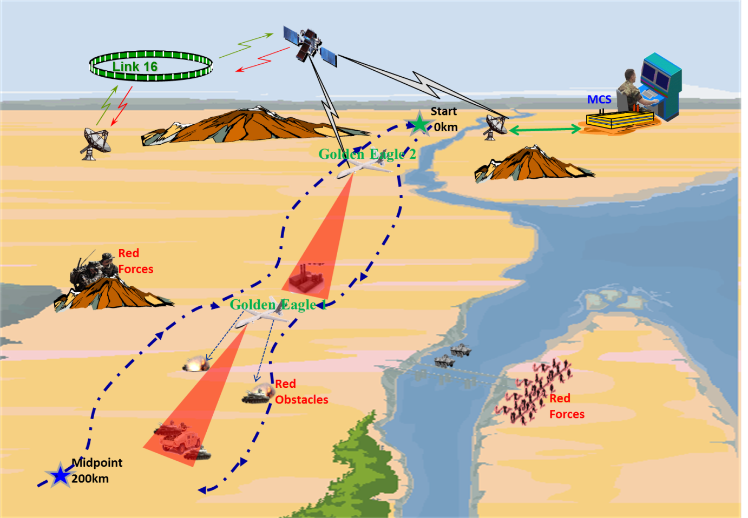

Figure 3. Scenario D Run Profile

## **E-TESTS**

### E-9 (Targeting)

Tests to determine the accuracy of the sensors on the UAV will be comprised of specific tests for both range and speed of target acquisition.

#### E-9a (Detection Range)

##### Objective

The objective of this test is to determine the accuracy of the sensors with regard to detection range.

##### Procedure

Detection range will be evaluated on a closed course under clear daylight conditions. Ground targets will be initially nominated beyond the sensor detection range. Range as a measure of the unobstructed linear distance between the UAV and the ground target will be recorded at the time of intercept. Range and other data will be recorded on data sheet E-9.

##### Data Analysis

The detection range assessment is quantitative and based on the UAV’s ability to acquire a target at an unobstructed linear distance of at least 70km. Recorded data will include the range of acquisition, temperature, humidity, and time of day, aborts, and mechanical and software failures.

#### E-9b (Detection Speed)

##### Objective

The objective of this test is to determine the accuracy of the sensors with regard to speed of detection.

##### Procedure

Detection speed will be evaluated on a closed course under clear daylight conditions. Ground targets will be initially nominated beyond the sensor detection range. Detection speed will be recorded at the time of intercept. Range and other data will be recorded on data sheet E-9.

##### Data Analysis

The detection speed assessment is quantitative and based on the UAV’s ability to acquire a target at rate of at least 1km/hr. Recorded data will include detection speed, temperature, humidity, and time of day, aborts, and mechanical and software failures.

### E-10 (Firepower)

Tests to determine the overall firepower of the UAV will be comprised of specific tests for both lethality and rate of fire.

##### E-10a (Lethality)

##### Objective

The objective of this test is to assess the lethality of the weaponry on the UAV.

##### Procedure

Lethality will be evaluated on the armor penetration. The UAV will be flown on a closed course and stationary ground targets will be provided and will form the basis of evaluation. Armor penetration for each successful hit will be recorded for each run on data sheet E-10.

##### Data Analysis

The lethality assessment will be quantitative in nature and will be based on the UAV’s ability to affect damage equivalent to 9cm of armor penetration or greater. Recorded data will include the number of hits, depth of penetration, aborts, and mechanical and software failures.

#### E-10b (Rate of Fire)

##### Objective

The objective of this test is to assess the rate of fire of the UAV.

##### Procedure

The rate of fire capability will be evaluated on the time to engage the target and launch four (4) consecutive missiles. The UAV will be flown on a closed course and stationary ground targets will be provided and will form the basis of evaluation. The time elapsed between target acquisition to missile firing will be recorded for each run on data sheet E-10.

##### Data Analysis

The rate of fire assessment is quantitative and based on the UAV’s ability to fire 4 missiles in 30 seconds. Time from target acquisition to missile firing should be less than five (5) seconds. Recorded data will include time between intercept and firing, aborts, and mechanical and software failures.

### E-1 (Speed)

#### Objective

The objective of this test is to assess the UAV’s air tactical mobility speed.

#### Procedure

The test will assess both sustained air speed and peak air speed. The test will be conducted on a closed course during daylight conditions that will permit visual observation. Data points recorded on data sheet E-1 will include air speed, speed over ground.

#### Data Analysis

The air tactical mobility speed assessment will be quantitative in nature. The UAV must achieve a top air speed of 120 nautical miles per hour and a sustained air speed of 90 nautical miles per hour over 20 minutes. Data points recorded on data sheet E-1 will include air speed, speed over ground, speed made good on waypoint, altitude, temperature, humidity, and wind speed. After each run, the UAV will be inspected for stress and structural flaws in the airframe.

### E-2 (Flight Time)

#### Objective

The objective of this test is to assess the UAV’s air tactical mobility flight time.

#### Procedure

The test will measure the UAV’s air tactical mobility flight time under normal flying conditions. The test will be conducted on a closed course during daylight conditions that will permit visual observation. The UAV will fly in a circuit in order to average the effects of wind speed and other environmental factors. Data points recorded on data sheet E-2 will include elapsed time and distance made good.

#### Data Analysis

The air tactical mobility flight time assessment will be quantitative in nature. The UAV must stay aloft for four hours at an altitude of 500 feet operating at 72 nautical miles per hour (80%). Data points recorded on data sheet E-2 will include flight time, altitude, distance made good, temperature, humidity, and wind speed. After each run, the UAV will be inspected for stress and structural flaws in the airframe.

# **5 OPERATIONAL SUITABILITY**

## **S-TESTS**

### S-1 (Interoperability)

#### Objective

The purpose of this test is to determine the accuracy of the data transfer between the UAV and Mission Command systems.

#### Procedure

The test will measure the UAV’s ability to communicate with critical Mission Command systems typical of shipboard and ground-based systems in a tactical combat environment. The test will utilize the Link-16 and WIN/T tactical networks to transmit data among MC systems while the UAV is flown on a closed course simulating an operationally relevant environment. Data will be recorded on data sheet S-1 and will include network throughput and packet loss.

#### Data Analysis

The interoperability assessment will be quantitative in nature. The UAV must demonstrate capability to transfer 1.5MB/s burs rate and 750Kb/s sustained during mission flight with less than 0.05% packet loss. Data points recorded on data sheet S-1 will include flight time, data rate, packet loss, altitude, transmission distance, temperature, humidity, and physical communication (transport layer) failures.

### S-2 (Human Systems Integration)

#### Objective

The purpose of this test is to determine the clarity of the video transmitted from the UAV during flight.

#### Procedure

The test will measure the UAV’s ability to send high-resolution video to shipboard and ground stations equivalent to a 10-megapixel resolution using standard MPEG compression. The UAV will be flown on a closed course simulating an operationally relevant environment while streaming a live compressed video feed to operators on the ground. Observations will be made regarding the legibility and usability of the live video feed by both the Mission Command and Intelligence communities. Data points recorded on data sheet S-2 will include total image resolution of the live video stream.

#### Data Analysis

The HSI test will be both quantitative and qualitative in nature. The UAV must be capable of providing video to shipboard and ground forces sufficient for a 10-megapixel resolution using standard MPEG compression. Furthermore, the shipboard/ground system must be daylight visible under expected operating conditions. Data points recorded on sheet S-2 will include total image resolution and screen daylight visibility.

# **ANNEX A: RESOURCE REQUIREMENTS**

|  |  |
| --- | --- |
| **Type of Resource** | **Required** |
| Test Articles | 2 UAVs and fuel vehicles |
| Test Sites | Training area |
| Instrumentation | Telemetry speed camera  Standard test equipment |
| Threat systems & simulators | Threat simulators  Mock UAVs |
| Simulations/Models | Computer simulations |
| Manpower/Personnel Training | Test sites/1 week |
| Special Requirements | Data collection system at test site |
| T&E Funding | $10 million |

# **ANNEX B: DATA SHEETS AND QUESTIONNAIRES**

|  |  |  |  |  |  |  |  |  |  |
| --- | --- | --- | --- | --- | --- | --- | --- | --- | --- |
| Test | Trial 1 | Trial 2 | Trial 3 | Trial 4 | Trial 5 | Trial 6 | Trial 7 | Trial 8 | Trial 9 |
| E-1 |  |  |  |  |  |  |  |  |  |
| Maximum altitude |  |  |  |  |  |  |  |  |  |
| Average time to maximum altitude |  |  |  |  |  |  |  |  |  |
| Average time at maximum speed |  |  |  |  |  |  |  |  |  |
| Average time at minimum speed |  |  |  |  |  |  |  |  |  |
|  |  |  |  |  |  |  |  |  |  |
| E-2 |  |  |  |  |  |  |  |  |  |
| Average set up time |  |  |  |  |  |  |  |  |  |
| Minimum set up time |  |  |  |  |  |  |  |  |  |
| Average number of people required for set up |  |  |  |  |  |  |  |  |  |
| Minimum number of people required for set up |  |  |  |  |  |  |  |  |  |
|  |  |  |  |  |  |  |  |  |  |
| E-3 |  |  |  |  |  |  |  |  |  |
| Avoidance rate |  |  |  |  |  |  |  |  |  |
| Survivability rate |  |  |  |  |  |  |  |  |  |
| Average detection time |  |  |  |  |  |  |  |  |  |
|  |  |  |  |  |  |  |  |  |  |
| E-4 |  |  |  |  |  |  |  |  |  |
| Mean time to engage enemy threat |  |  |  |  |  |  |  |  |  |
| Percent of enemy threats hit |  |  |  |  |  |  |  |  |  |
|  |  |  |  |  |  |  |  |  |  |
| E-5 |  |  |  |  |  |  |  |  |  |
| Targets successfully detected |  |  |  |  |  |  |  |  |  |
| Targets successfully classified |  |  |  |  |  |  |  |  |  |
|  |  |  |  |  |  |  |  |  |  |
| E-6 |  |  |  |  |  |  |  |  |  |
| Throughput |  |  |  |  |  |  |  |  |  |
|  |  |  |  |  |  |  |  |  |  |
| E-7 |  |  |  |  |  |  |  |  |  |
| Successful mission |  |  |  |  |  |  |  |  |  |
|  |  |  |  |  |  |  |  |  |  |
| E-8 |  |  |  |  |  |  |  |  |  |
| Avoid detection |  |  |  |  |  |  |  |  |  |
| Evade threats |  |  |  |  |  |  |  |  |  |
|  |  |  |  |  |  |  |  |  |  |
| E-9 |  |  |  |  |  |  |  |  |  |
| Target range |  |  |  |  |  |  |  |  |  |
| Target speed |  |  |  |  |  |  |  |  |  |
|  |  |  |  |  |  |  |  |  |  |
| E-10 |  |  |  |  |  |  |  |  |  |
| Lethality |  |  |  |  |  |  |  |  |  |
| Rate of fire |  |  |  |  |  |  |  |  |  |
|  |  |  |  |  |  |  |  |  |  |

Questionnaire for S-1 Interoperability

Name: ________________________

Rank: ________________________

MOS: ________________________

1. Ease of data transfer:

__Excellent __Very Good __Average __Fair __Poor

Comments: ______________________________________________________

________________________________________________________________

2. Accuracy of data transfer:

__Excellent __Very Good __Average __Fair __Poor

Comments: ______________________________________________________

________________________________________________________________

3. Ease of manipulating data:

__Excellent __Very Good __Average __Fair __Poor

Comments: ______________________________________________________

________________________________________________________________

4. Ease of tracking data:

__Excellent __Very Good __Average __Fair __Poor

Comments: ______________________________________________________

________________________________________________________________

Questionnaire for S-2 HSI

Name: ________________________

Rank: ________________________

MOS: ________________________

1. Ease of comprehension the maintenance manual:

__Excellent __Very Good __Average __Fair __Poor

Comments: ______________________________________________________

________________________________________________________________

2. Ease of seeing the visual warnings:

__Excellent __Very Good __Average __Fair __Poor

Comments: ______________________________________________________

________________________________________________________________

3. Ease of hearing the audio warnings:

__Excellent __Very Good __Average __Fair __Poor

Comments: ______________________________________________________

________________________________________________________________

4. Ease of comprehension the data on the display:

__Excellent __Very Good __Average __Fair __Poor

Comments: ______________________________________________________

________________________________________________________________

# **ANNEX C: OMITTED**

# **ANNEX D: DATA ANALYSIS PLAN**

|  |  |  |
| --- | --- | --- |
| **Variable** | **Control** | **Factor Levels/Treatments** |
| Command and Control | Systematically varied | Centralized, decentralized |
| Combat System | Systematically varied | Supported, surge, and peak |
| Sensors | Systematically varied | Intermittent, continuous |
| Air Target | Tactically varied | FW, RW, UAV |
| Mission Routes | Tactically varied | Environment, threats |
| Software | Held Constant | Version 1 |
| Doctrine | Held Constant | IAW specified tactics plan |
| Training | Held Constant | IAW user |
| Logistics Support | Held Constant | IAW logistics rep |
| Communications | Held Constant | Link 16 |
| System/Equipment Failures | Uncontrolled | As occurs |
| Weather | Uncontrolled | As occurs |
| Temperature | Uncontrolled | Ambient |